**Creative Industries information for applicants**

**Background**

The Creative Industries Clusters Programme recognises that there are different types of data and evidence which can inform our understanding of the Creative Industries, how they are currently supported and how they interact with research organisations. Some of these data will be useful to make publicly available as exciting and innovative collaborative R&D programmes are scoped and established for the Creative Industries Clusters Programme.

The Programme is exploring different additional datasets and analyses which can be made available to applicants and eventual award holders and has embarked on phased activity to collect information relevant to the Programme since August 2017 and the launch of the Policy and Evidence Centre in Summer 2018.

The Programme has commissioned an initial analysis of the 2015 data from the Office of National Statistics to be made available to applicants. Further data and analyses may be made available in 2018 to support bid development between Stage 1 and Stage 2 and to inform successful award holders of the Creative R&D Partnerships and the Policy and Evidence Centre.

NESTA have provided an analysis for the Programme of the 2015 ONS data on employment and business specialisation. This analysis builds on the methodology used by NESTA for the *Geography of Creativity in the UK: Creative cluster, creative people and creative networks* (2016) report by Juan Mateos-Garcia and Hasan Bakhshi.[1]

**The Data**

The information below includes the following:

* A series of notes and caveats to support how the data are interpreted and used.
* The data visualised as maps of Creative Industries activity across the UK presented in aggregate across the Creative Industries activity and at sub-sector level.
* The raw data presented as a downloadable csv table.

**Notes and caveats for the interpretation and use of the data**

The data in the table and maps have been extracted from two sources: the [Interdepartmental Business Register](https://www.ons.gov.uk/aboutus/whatwedo/paidservices/interdepartmentalbusinessregisteridbr) (IDBR), which contains administrative data about VAT / PAYE-registered businesses in the UK, and the [Business Register and Employment Survey](https://www.ons.gov.uk/surveys/informationforbusinesses/businesssurveys/businessregisterandemploymentsurvey) (BRES), which contains information about employment. These data have been accessed from [Nomis](http://www.nomisweb.co.uk/), a website with information about labour market statistics maintained by the ONS.

Data in Nomis can be queried by sector (based on SIC codes) and location. We have done this using the DCMS definition of the creative industries, which use 4-digit SIC codes to define creative sub-sectors which can be aggregated into total creative industries statistics ([see appendix here for specific codes](https://www.gov.uk/government/uploads/system/uploads/attachment_data/file/523024/Creative_Industries_Economic_Estimates_January_2016_Updated_201605.pdf)). We measure levels of creative industries activity at the Travel To Work Area (TTWA) level. TTWAs are official statistics which capture local labour markets using commuting data from the census. TTWAs were last updated using 2011 data. TTWAs capture functional economic areas and have been previously used to map creative clusters in Chapain et al. (2010) and Mateos-Garcia and Bakhshi (2016).

Some observations about the data and maps:

* BRES data captures employees in businesses and working owners, but does not include freelancers and self-employed.
* BRES data for Northern Ireland are not available from Nomis. Some BRES data are available from NISRA (the Northern Ireland Statics and Research Agency) but not at the level of sectoral and geographical resolution required to replicate the analysis we have carried out elsewhere in the UK. This means the tables and maps do not provide information about creative sector and sub-sector employment in Northern Ireland. The data table published with Nesta’s Geography of Creativity use IDBR data obtained from the ONS to measure creative industries workers in Northern Ireland up to 2014. It is available for download [here](http://www.nesta.org.uk/publications/geography-creativity-uk).
* Northern Ireland business count data are not available at the TTWA level from Nomis. To address this, we obtained the data at the Local Authority District (LAD) from NOMIS, and converted it into TTWAs using a lookup based on the distribution of postcodes in LADs over TTWAs.
* Business counts totals are rounded up to the next 5 and employment totals are rounded to the next 100 to comply with ONS disclosure guidelines.
* In addition to business counts and employment totals, we have also estimated location quotients that measure the relative specialisation of a location in a sector (that is, how important is a sector in a TTWA compared to the national average). A score in LQ >1 means that a TTWA is relatively specialised in a sector / the sector tends to cluster in the location.
* In the maps, we have represented LQs instead of total levels of in order to avoid a situation where the maps are dominated by the locations with the largest populations and in particular London. In addition to representing absolute values for location quotients, we have also split TTWAs into their corresponding decile in the LQ distribution: In other words, we have split the data into 10 ‘bins’ going from the bottom 10% (Decile 1) in terms of their LQ score to the top 10% (Decile 10). The reason for doing this is that decile scores are less distorted by extreme values of LQs which are sometimes observed in smaller areas.
* Each map includes labels for the top 10 TTWAS in the sector in terms of total business counts in the relevant creative sector or subsector. We included them in order to provide some signposts helping navigate the map.

Notes and caveats to be added from Juan

The maps report LQs instead of totals because otherwise they would be completely dominated by London.

-Both sets of maps include labels for the top 10 TTWAs in a sector in terms of total business counts. Their goal is to help with navigation.

- no employment data for Northern Ireland

**Juan:**

Could we particularly focus on please:

* Data limitations and caveats
* Overview of what this data can be used to say and what it can’t
* Definitions re: what is included within employment and business counts (feel free if it is easiest to cross-reference to *Geography of Creativity*)

**The data as maps of Creative Industries activity across the United Kingdom**

**Table of Maps pp. 4-13**

Advertising and Marketing 4

Architecture 5

Crafts 6

Design 7

Film, TV, Video, Radio & Photography 8

IT, Software and Computer Services 9

Museums, Galleries and Libraries 10

Music, Performing Arts and Visual Arts 11

Publishing 12

All Creative Industries 13

**The Underlying Data pp. 14**

## Advertising and Marketing

**Business Count**

**Employment**

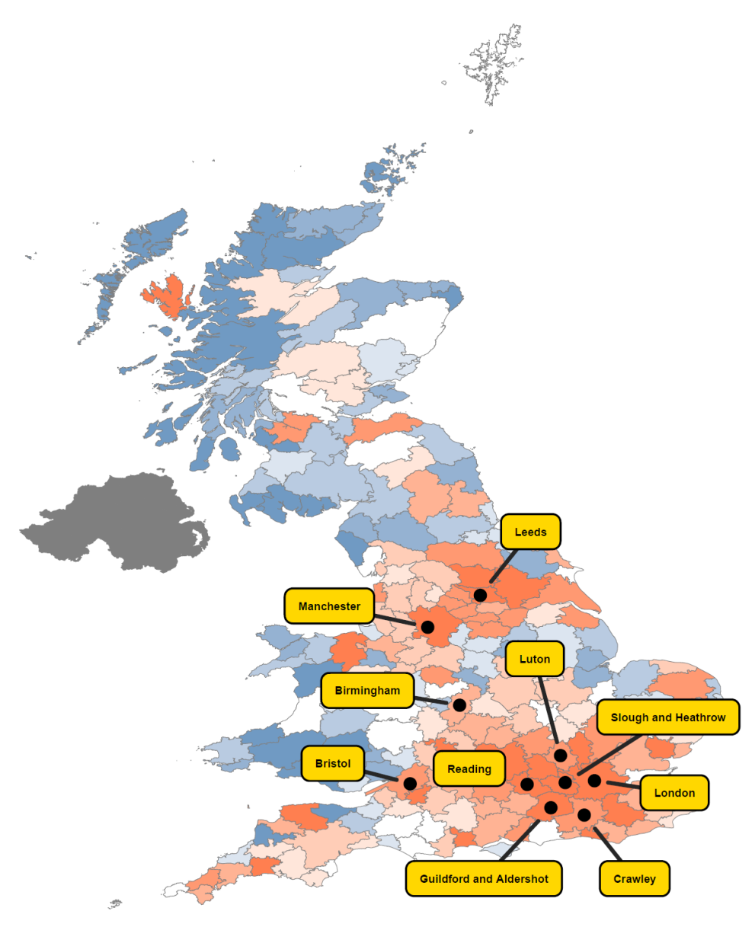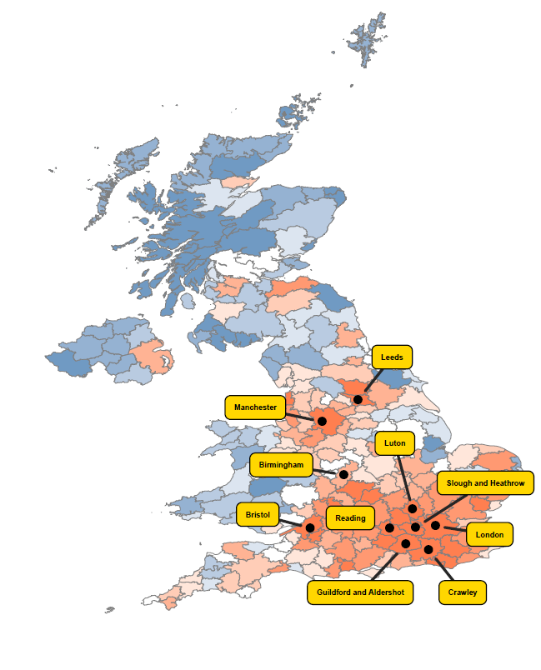

## Architecture

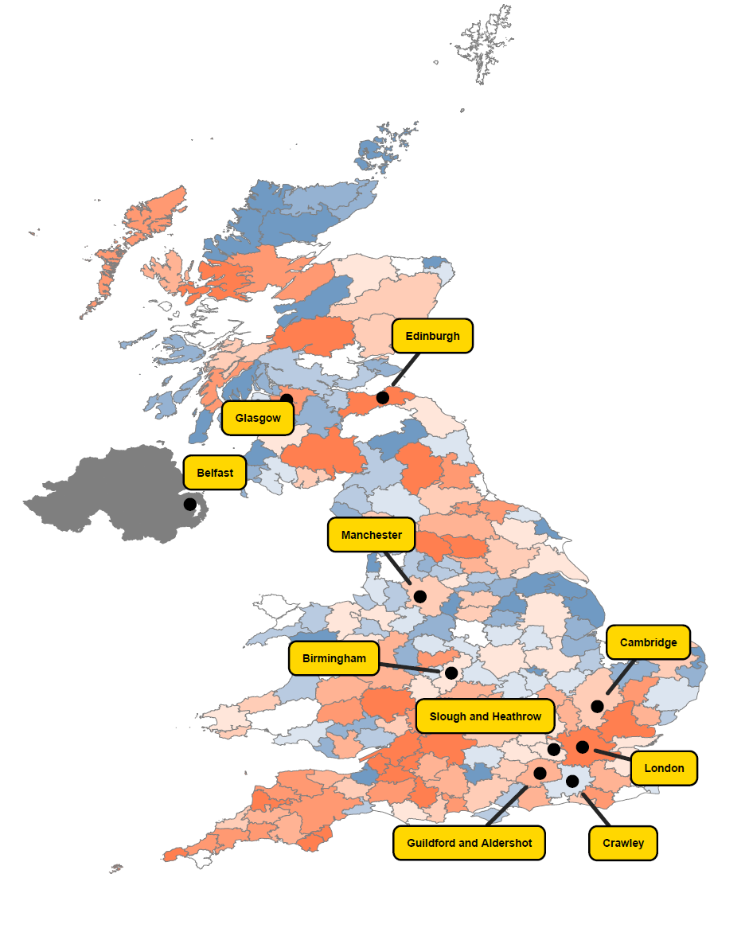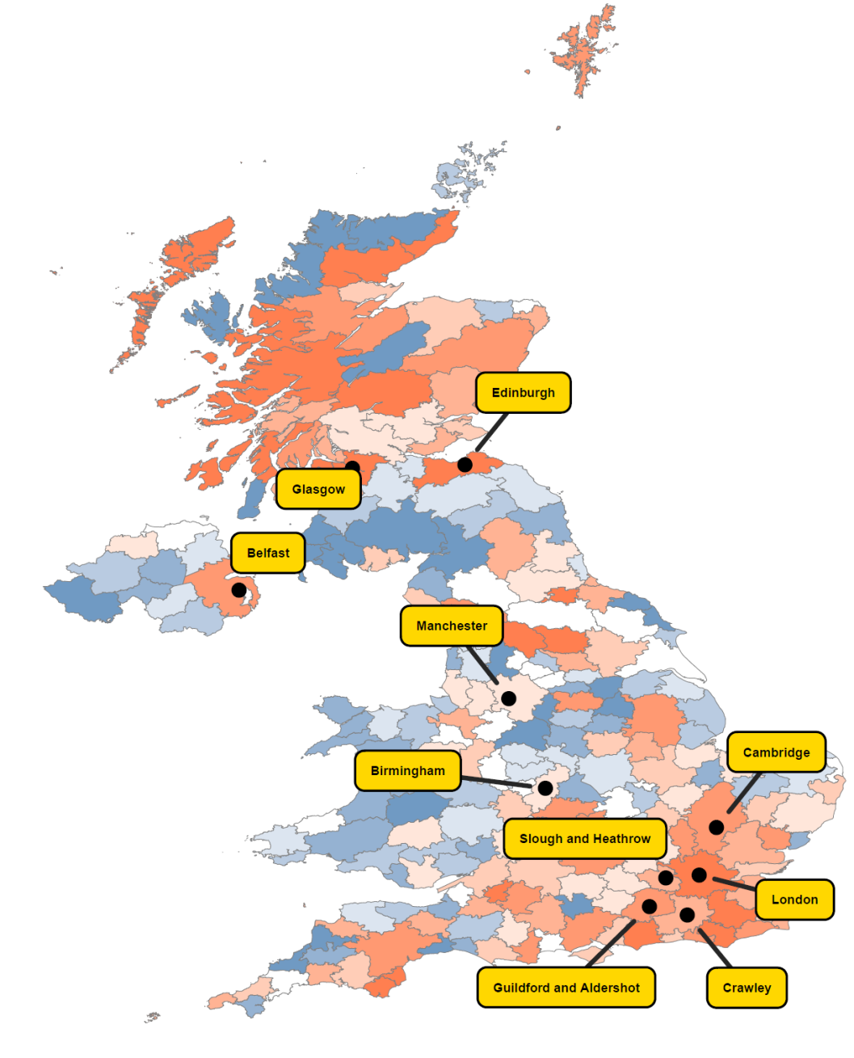

**Business Count**

**Employment**

## Crafts

**Business Count**

**Employment**

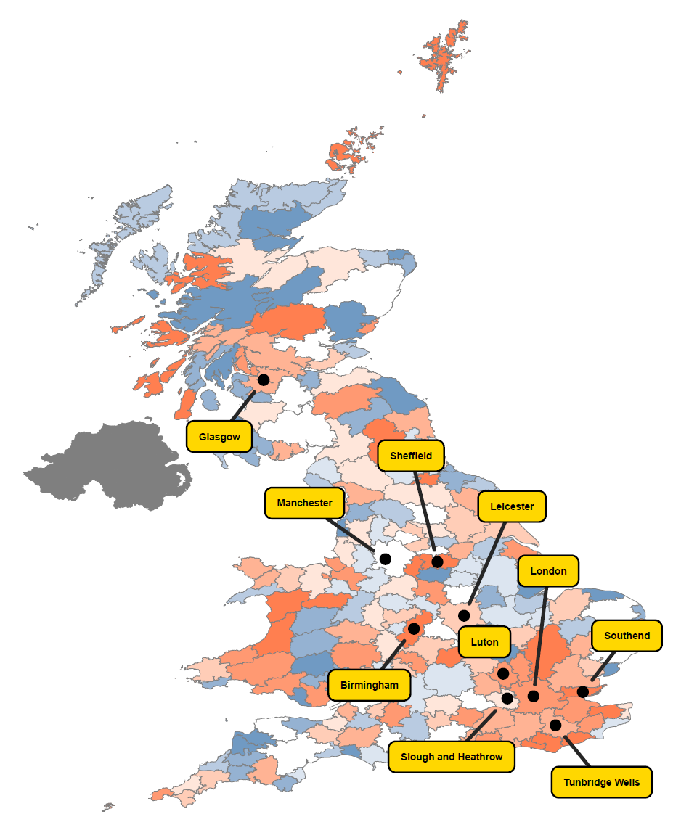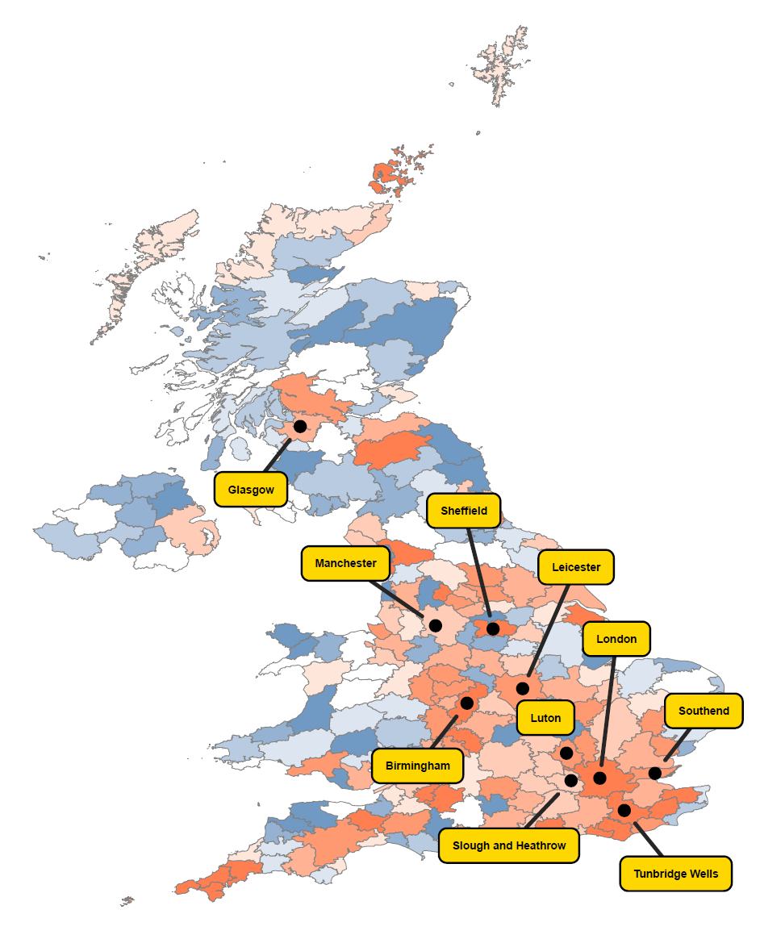

## Design

**Business Count**

**Employment**

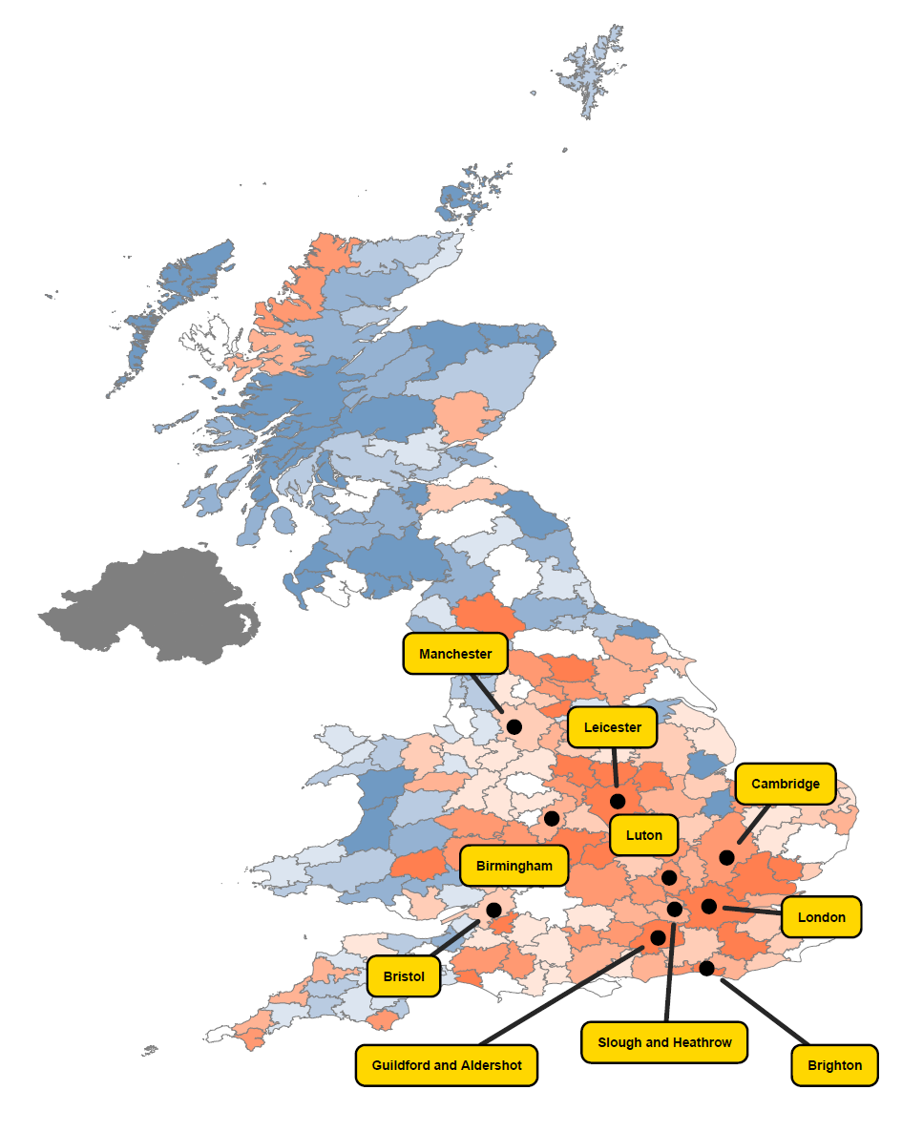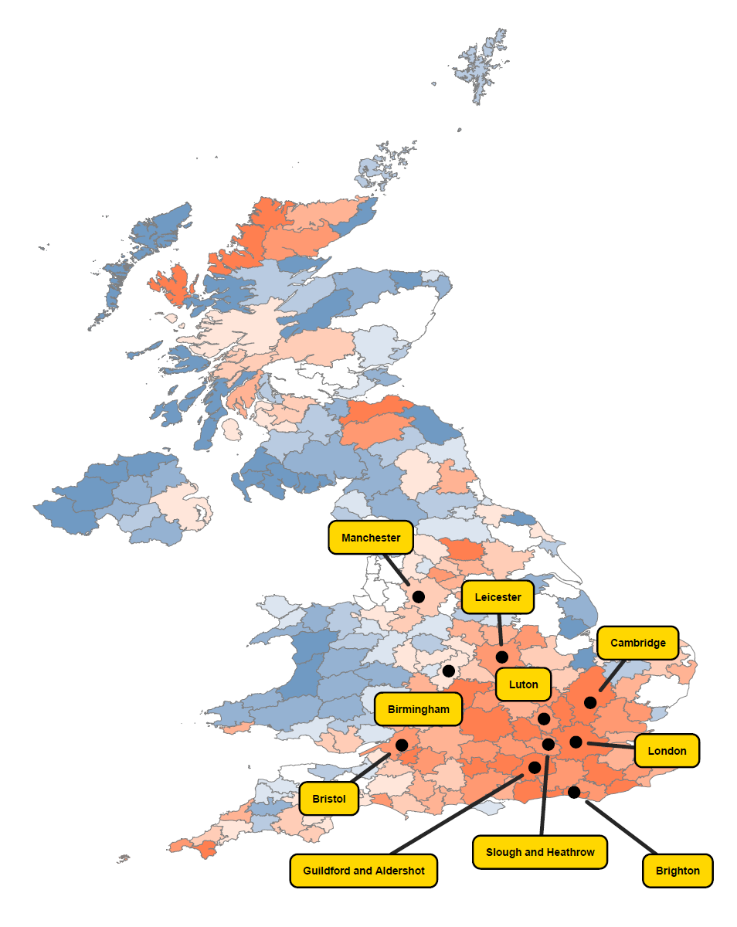

## Film, TV, Video, Radio & Photography

**Employment**

**Business Count**

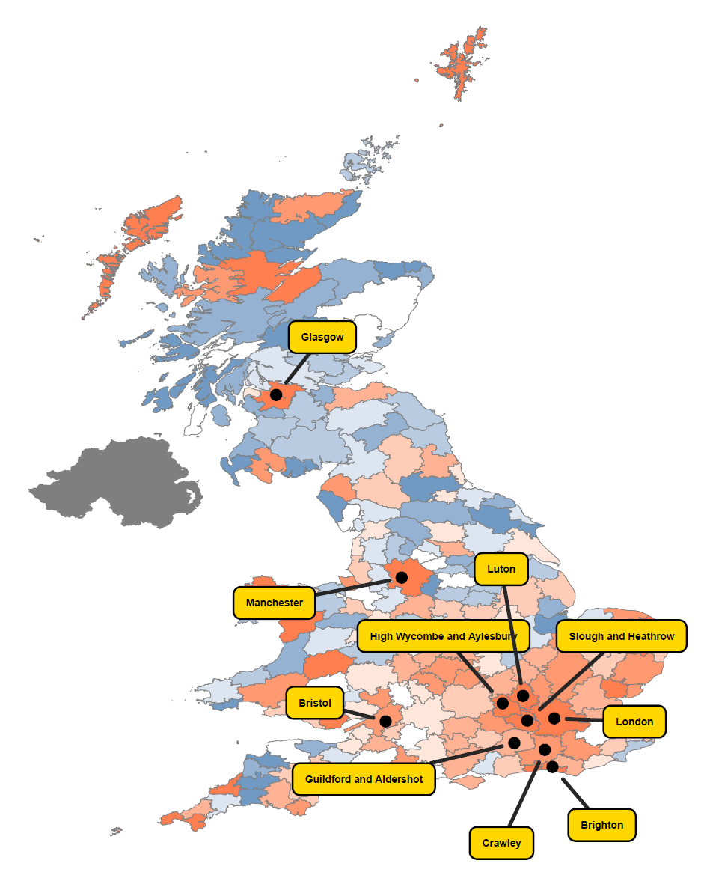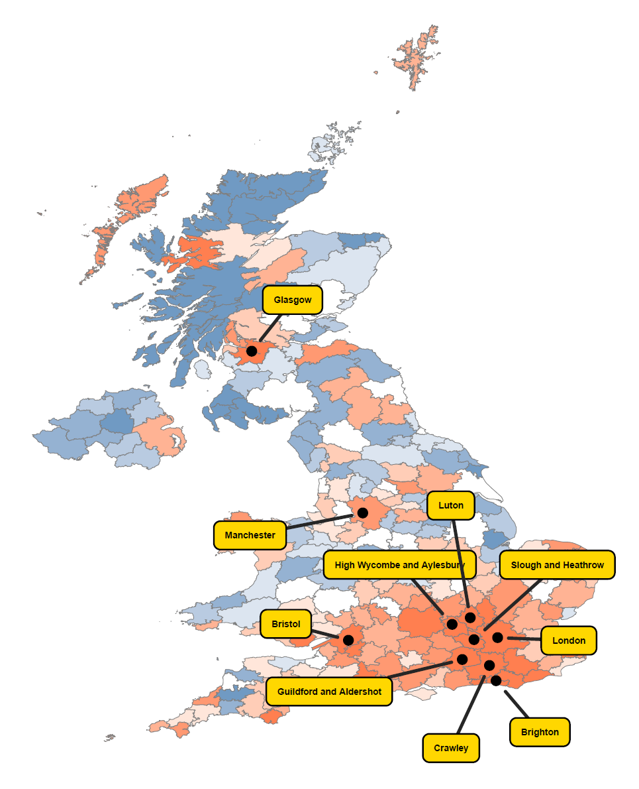

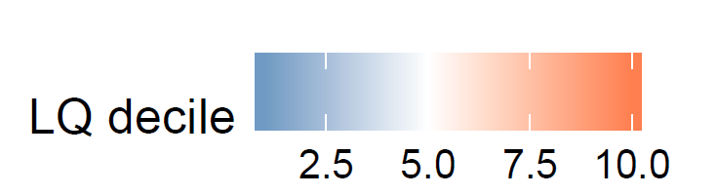IT, Software and Computer Services

**Employment**

**Business Count**

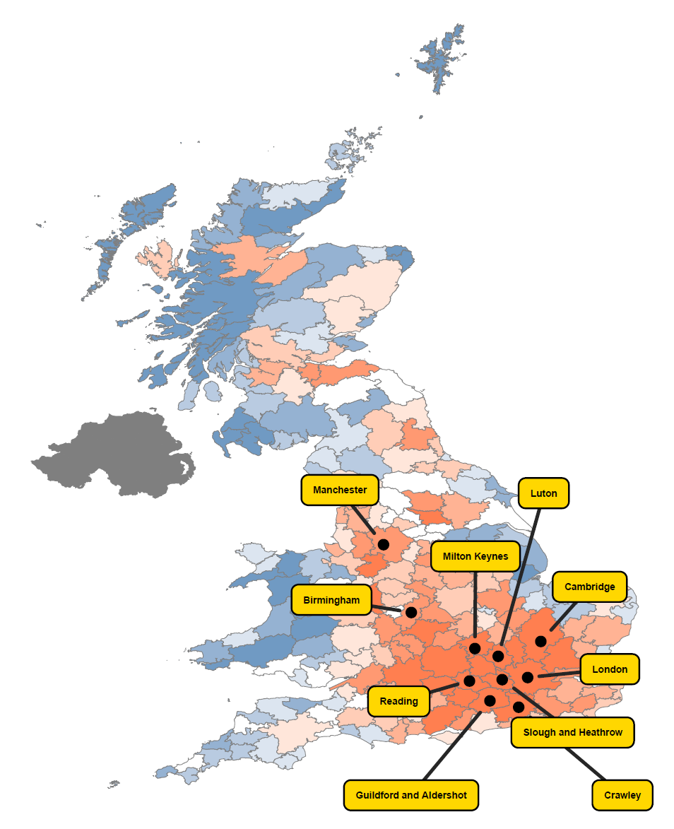

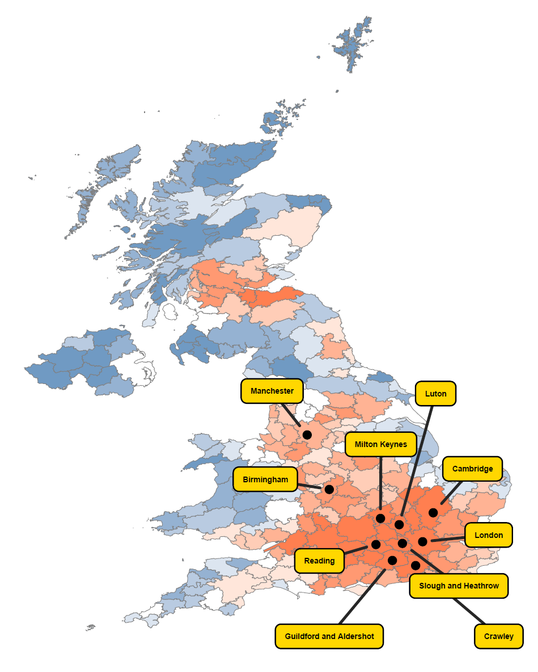

## Museums, Galleries and Libraries

**Employment**

**Business Count**

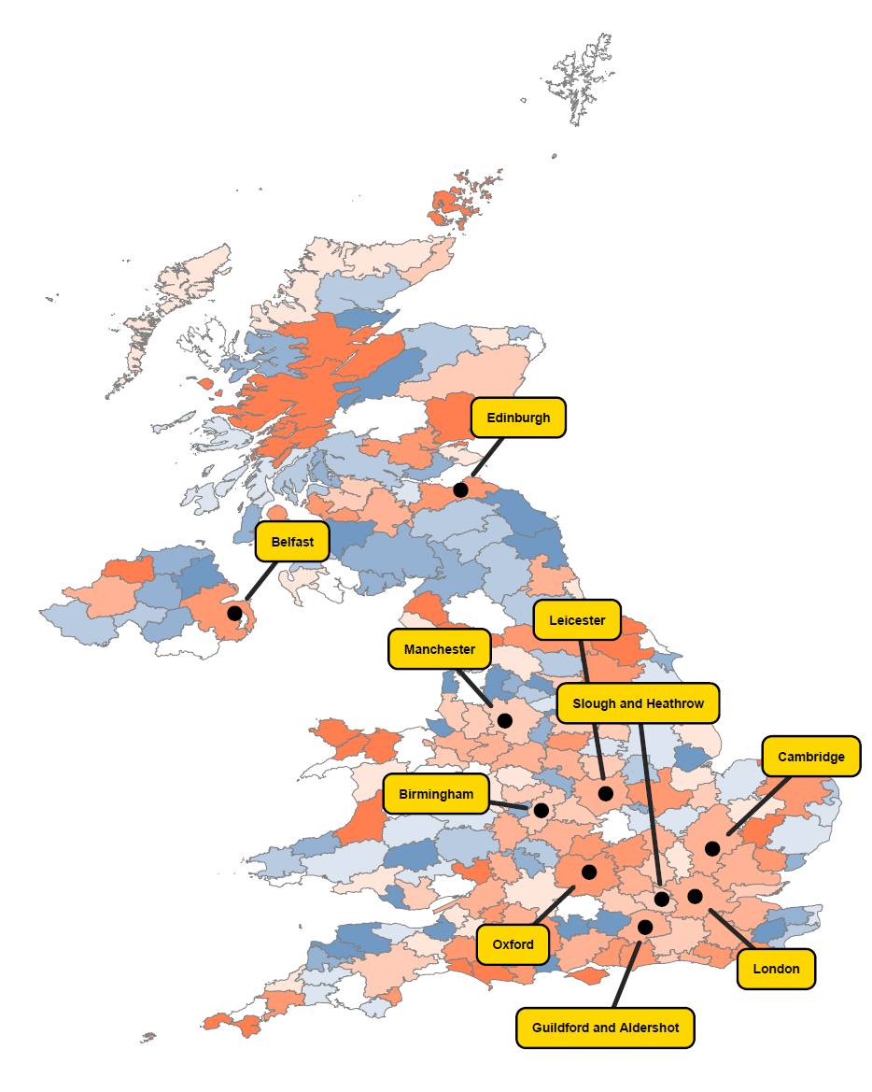

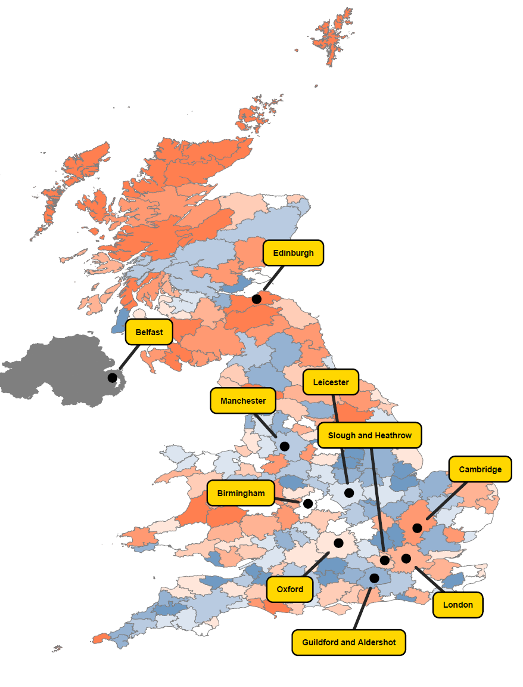

## Music, Performing Arts and Visual Arts

**Employment**

**Business Count**

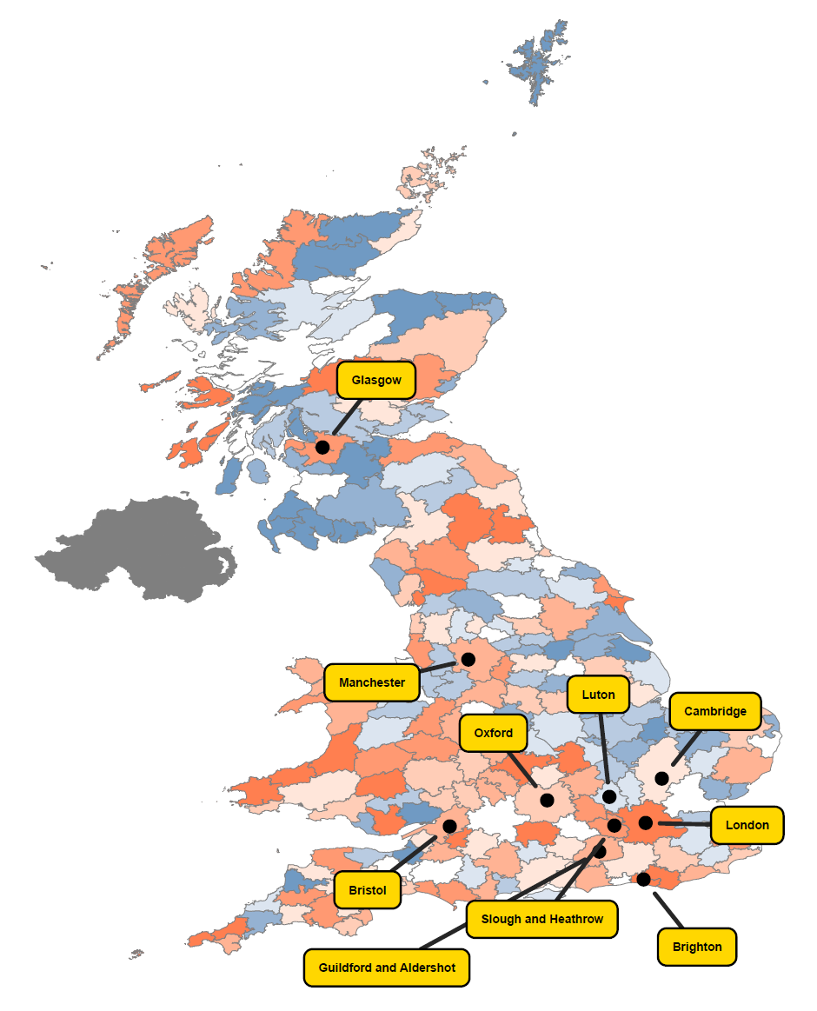

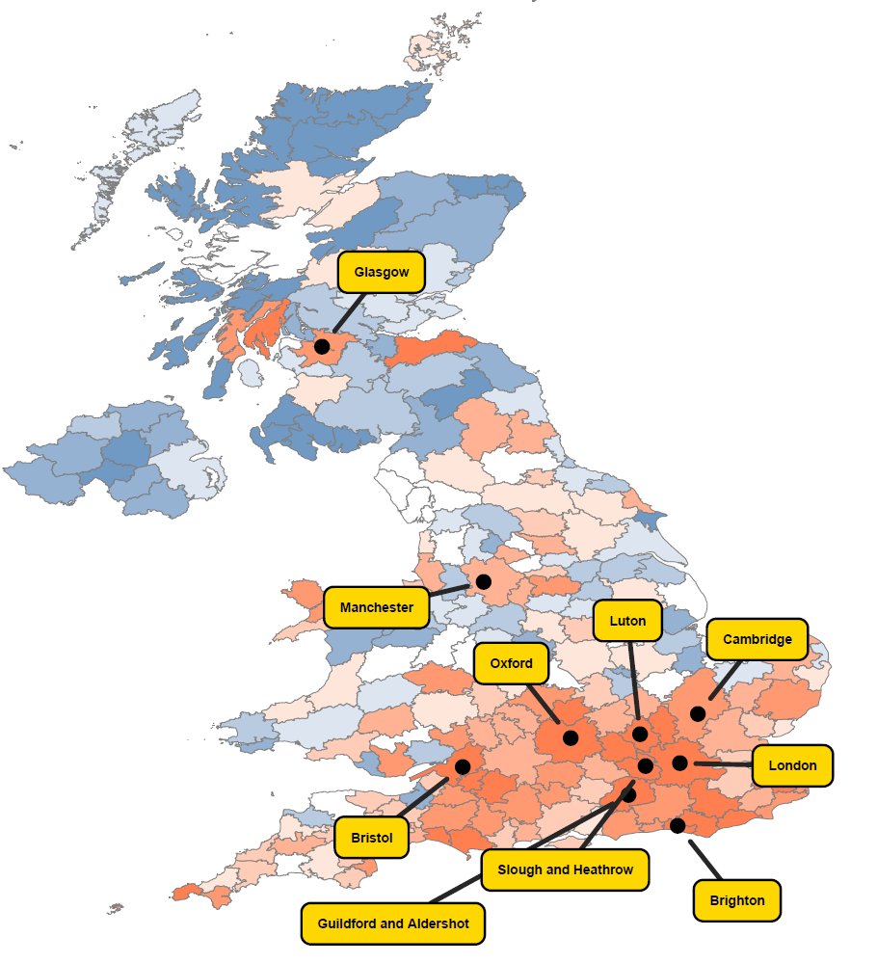

## Publishing

**Employment**

**Business Count**

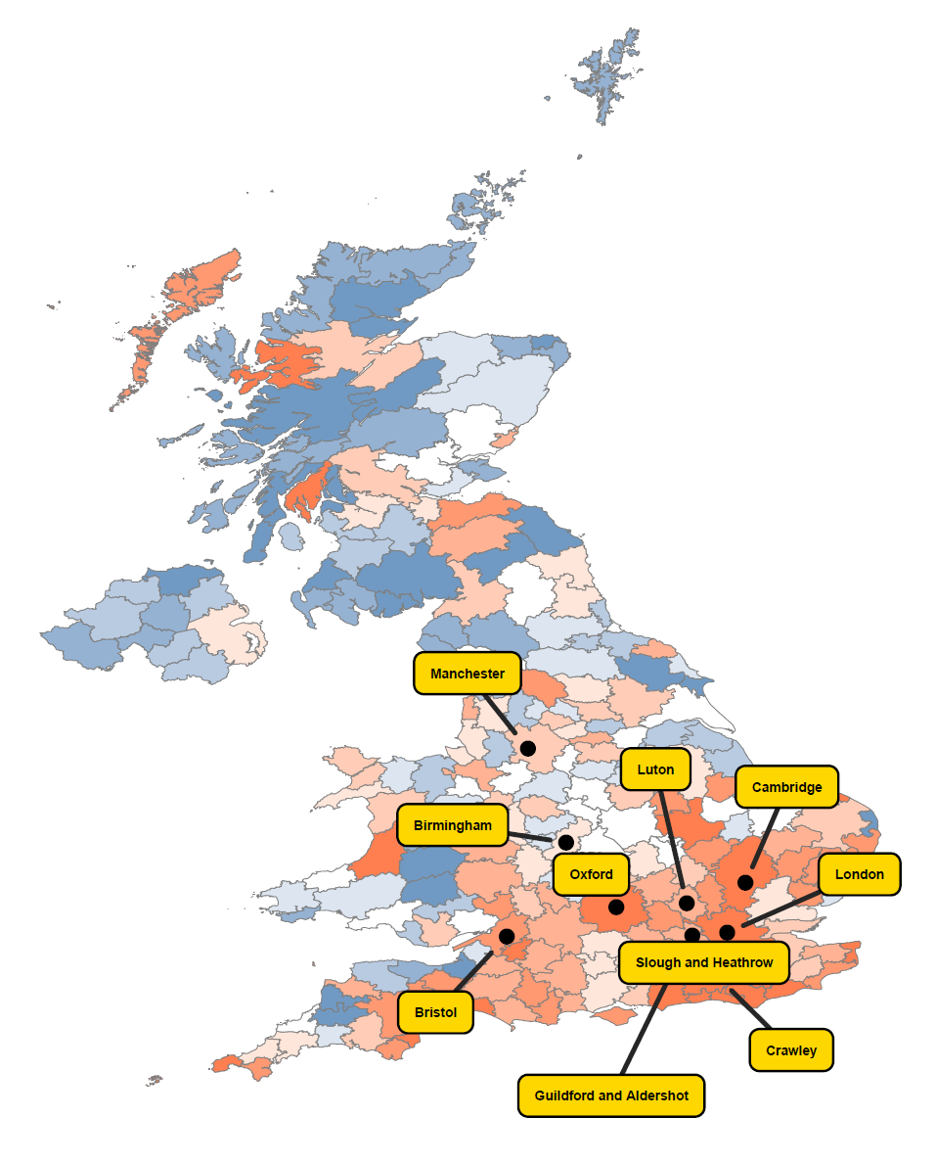

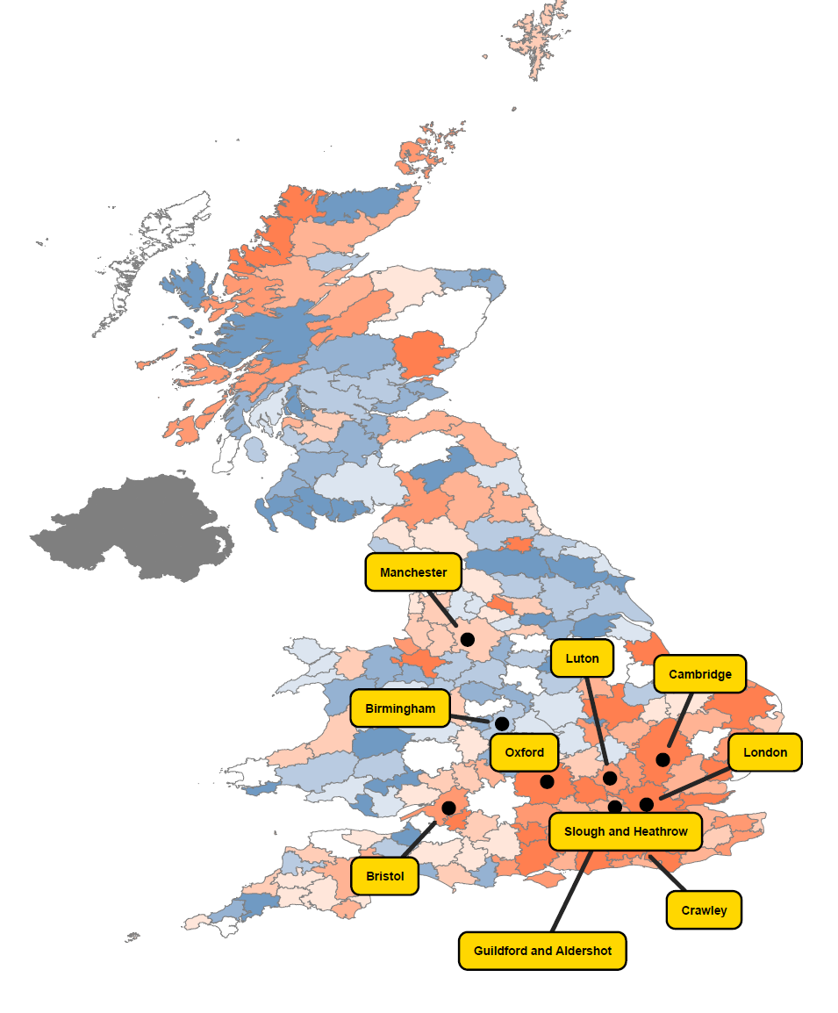

## All Creative Industries

**Employment**

**Business Count**

**The Underlying Data**

The embedded file below, as a excel spreadsheet, provides the underlying data and analysis used to produce the maps on pp.4-13. Please read the section on notes and caveats relating to the use of this data on p. XX before undertaking any further analysis.



1. <http://www.nesta.org.uk/sites/default/files/the_geography_of_creativity_in_the_uk.pdf> and the data made available by NESTA <http://www.nesta.org.uk/publications/geography-creativity-uk>